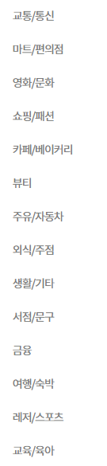

**참조 링크**

[**https://www.banksalad.com/cards/questions**](https://www.banksalad.com/cards/questions)